Course name:
Image Processing
Course code:
CS 383

Team members:
sn | Name | ID | Sec | Grade
1 | Kirolos Magdy | 200039720 | Tue 1/3
2 | Ahmed Mohamed Fatouh | 200039891 | Tue 1/3
3 | Ahmed Mohamed Ahmed | 200037240 | Tue 1/3
4 | Mazen Tarek | 200036954 | Tue 1/3

Under supervision of:
Prof. Dr. Waleed Hamdy
TA. Your section TA. Mariam Reda

Spring 2026 / 2027
Image Processing Pipeline for Noisy Image Enhancement and Edge Detection

- Introduction
Image processing is an important part of computer vision because it helps improve image quality and make image details clearer. In many cases, images may contain noise, low contrast, blurred details, or unclear edges, which makes them harder to analyze. For this reason, image processing techniques are used to clean and enhance images before extracting useful information from them.
In this project, a noisy image dataset from Kaggle[1] is used. The code selects an image from the dataset and applies several processing steps to it. First, the image is resized to 256×256 pixels and converted to grayscale. Then, Median Filter and Gaussian Blur are used to reduce noise and smooth the image.
After that, CLAHE is applied to improve the contrast, and sharpening is used to make the details more visible. The project also uses Sobel and Canny edge detection to find the important edges in the image. In addition, segmentation techniques such as dilation, morphological closing, and median filtering are used to make the detected edges clearer and more connected.
Finally, the detected Canny edges are added in red over the original image to create an overlay result. The final output shows the image in different stages, such as grayscale, filtered, enhanced, sharpened, Sobel, Canny, segmentation, and overlay. This project shows how different image processing techniques can work together in one pipeline to improve and analyze noisy images.

- Code
!pip install kagglehub
import kagglehub
path = kagglehub.dataset_download(
"goutham1208/multi-noises-for-image-denoising"
)
print("Dataset Path:", path)
base_path = path + "/dataset"
sp_path = base_path + "/noises"
import cv2
import numpy as np
import matplotlib.pyplot as plt
import os
import random
print(os.listdir(base_path + "/noises"))
def preprocessing(img):
img = cv2.resize(img, (256,256))
gray = cv2.cvtColor(img, cv2.COLOR_BGR2GRAY)
return gray
def filtering(gray):
# Median Filter
median = cv2.medianBlur(gray, 3)
# Gaussian Blur
clean = cv2.GaussianBlur(median, (3,3), 0)
# CLAHE Enhancement
clahe = cv2.createCLAHE(
clipLimit=2.0,
tileGridSize=(8,8)
)
enhanced = clahe.apply(clean)
# Sharpen
blur = cv2.GaussianBlur(enhanced, (0,0), 3)
sharp = cv2.addWeighted(
enhanced,
1.6,
blur,
-0.6,
0
)
return clean, enhanced, sharp
def edge_detection(sharp):
# Sobel
sobelx = cv2.Sobel(
sharp,
cv2.CV_64F,
1,
0,
ksize=3
)
sobely = cv2.Sobel(
sharp,
cv2.CV_64F,
0,
1,
ksize=3
)
sobel = cv2.magnitude(sobelx, sobely)
sobel = cv2.normalize(
sobel,
None,
0,
255,
cv2.NORM_MINMAX
)
# Canny
blur2 = cv2.GaussianBlur(sharp, (5,5), 0)
canny = cv2.Canny(
blur2,
80,
150
)
return sobel, canny
def segmentation(sharp):
edges = cv2.Canny(sharp, 80, 150)
kernel = np.ones((3,3), np.uint8)
seg = cv2.dilate(edges, kernel, iterations=1)
seg = cv2.morphologyEx(
seg,
cv2.MORPH_CLOSE,
kernel
)
seg = cv2.dilate(seg, kernel, iterations=2)
seg = cv2.medianBlur(seg, 5)
return seg
def full_pipeline(img):
# Preprocessing
gray = preprocessing(img)
# Filtering
clean, enhanced, sharp = filtering(gray)
# Edge Detection
sobel, canny = edge_detection(sharp) # sopel canny
# Segmentation
seg = segmentation(sharp)
return gray, enhanced, clean, sharp, sobel, canny, seg
def overlay_edges(img, canny):
img = cv2.resize(img, (256,256))
edges_colored = np.zeros_like(img) #black pic
edges_colored[canny > 0] = [0,0,255] # Make edge pixels red
overlay = cv2.addWeighted( # Merge two layers
img,
0.9,
edges_colored,
1,
0
)
return overlay
def show_result(path):
image_extensions = [".jpg", ".jpeg", ".png", ".bmp"]
image_files = []
for root, dirs, files in os.walk(path):
for file in files:
if file.lower().endswith(tuple(image_extensions)):
image_files.append(os.path.join(root, file))
if len(image_files) == 0:
print("No image files found.")
return
img_path = random.choice(image_files)
img = cv2.imread(img_path)
if img is None:
print("OpenCV could not read this image:")
print(img_path)
return
gray, enhanced, clean, sharp, sobel, canny, seg = full_pipeline(img)
overlay = overlay_edges(img, canny)
titles = [
"Gray",
"Enhanced",
"Filtered",
"Sharpen",
"Sobel",
"Canny",
"Segment",
"Overlay"
]
images = [
gray,
enhanced,
clean,
sharp,
sobel,
canny,
seg,
cv2.cvtColor(overlay, cv2.COLOR_BGR2RGB)
]
plt.figure(figsize=(14, 10))
for i in range(8):
plt.subplot(3, 3, i + 1)
if i == 7:
plt.imshow(images[i])
else:
plt.imshow(images[i], cmap="gray")
plt.title(titles[i])
plt.axis("off")
plt.suptitle("FINAL IMAGE PROCESSING PIPELINE")
plt.show()
sp_path = base_path + "/noises"
show_result(sp_path)

- Gray Stage
The Gray output is the first processed version of the input image. In this stage, the image is converted from rgp color format into grayscale. This makes the image easier to process because most filtering and edge detection techniques work better on single-channel images. In the displayed result, the noise is still visible because this stage only changes the color format and does not remove noise yet.
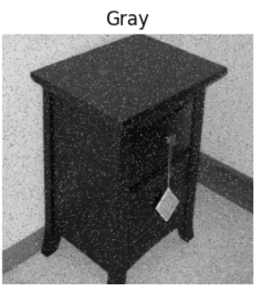
Related code:
gray = cv2.cvtColor(img, cv2.COLOR
_BGR2GRAY)

- Filtered Stage
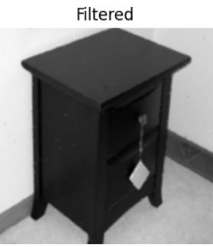
The Filtered output represents the image after noise reduction. The code first applies a Median Filter, which is effective for reducing random noise such as salt-and-pepper noise. After that, Gaussian Blur is applied to smooth the image and reduce small variations. This stage makes the image cleaner than the grayscale version and prepares it for contrast enhancement and edge detection.
Related code:
median = cv2.medianBlur(gray, 3)
clean = cv2.GaussianBlur(median, (3, 3), 0)

- Enhanced Stage
The Enhanced output is produced using CLAHE, which stands for Contrast Limited Adaptive Histogram Equalization. This technique improves the contrast of the image by working on small regions instead of the whole image at once. It makes hidden details more visible while limiting over-enhancement. In the displayed output, the object details become clearer compared to the filtered image.
Related code:
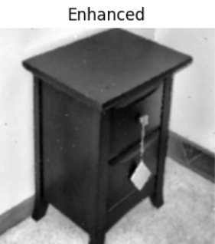
clahe = cv2.createCLAHE(clipLimit=2.0, tileGridSize=(8, 8))
enhanced = clahe.apply(clean)

- Sharpen Stage
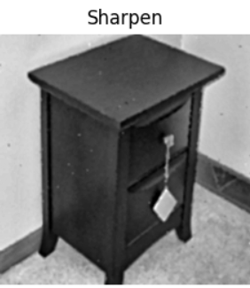
The Sharpen output increases the visibility of edges and fine details. The code creates a blurred copy of the enhanced image and then combines it with the enhanced image using weighted addition. This process strengthens the differences between neighboring pixels, making boundaries and texture details more noticeable. This stage is useful before edge detection because clearer edges can produce better edge maps.
Related code:
blur = cv2.GaussianBlur
(enhanced, (0, 0), 3)
sharp = cv2.addWeighted
(enhanced, 1.6, blur, -0.6, 0)
- Sobel Stage
The Sobel output shows the edges detected using the Sobel operator. Sobel detects edges by measuring changes in pixel intensity. The code calculates edges in the x-direction and y-direction, then combines both results to show the overall edge strength. This stage highlights the main boundaries of the object, such as the edges of the chair, using bright lines on a dark background.
Related code:
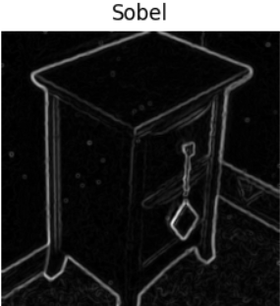
sobelx = cv2.Sobel(sharp, cv2.CV_64F, 1, 0, ksize=3)
sobely = cv2.Sobel(sharp, cv2.CV_64F, 0, 1, ksize=3)
sobel = cv2.magnitude(sobelx, sobely)

- Canny Stage
The Canny output shows a cleaner edge map than Sobel. Before applying Canny, the image is slightly blurred to reduce small noisy details. Canny then uses two threshold values to decide which pixels represent strong edges, weak edges, or non-edges. In this project, the thresholds are 80 and 150. The result is a clear outline of the important boundaries in the image.
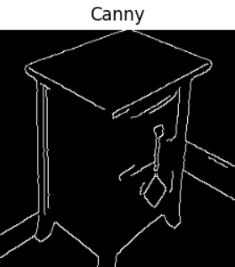
Related code:
blur2 = cv2.GaussianBlur(sharp, (5, 5), 0)
canny = cv2.Canny(blur2, 80, 150)

- Segment Stage
The Segment output is created using an edge-based segmentation process. The code starts with Canny edges, then applies dilation to make the detected edges thicker and more connected. Morphological closing is used to close small gaps between edge parts. Another dilation step strengthens the regions further, and Median Blur is finally applied to clean small unwanted pixels. This stage helps highlight the main detected regions and boundaries in a clearer form.
Related code:
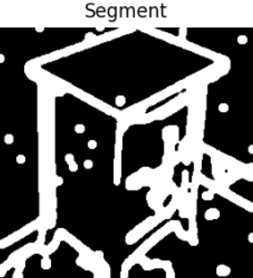
edges = cv2.Canny(sharp, 80, 150)
seg = cv2.dilate(edges, kernel, iterations=1)
seg = cv2.morphologyEx(seg, cv2.MORPH_CLOSE, kernel)
seg = cv2.dilate(seg, kernel, iterations=2)
seg = cv2.medianBlur(seg, 5)

- Overlay Stage
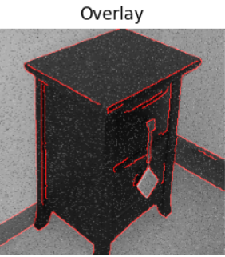
The Overlay output combines the detected Canny edges with the original resized image. The edge pixels are colored in red and then merged with the original image using weighted addition. This makes the detected boundaries easier to understand visually because the edges are shown directly on top of the object instead of being displayed separately in black and white.
Related code:
edges_colored[canny > 0] = [0, 0, 255]
overlay = cv2.addWeighted(img, 0.9,
edges_colored, 1, 0)

- Data availability
[1] Multi Noises for Image Denoising From Kaggle
[2] GitHub link for Image Processing Pipeline for Noisy Image Enhancement and Edge Detection

